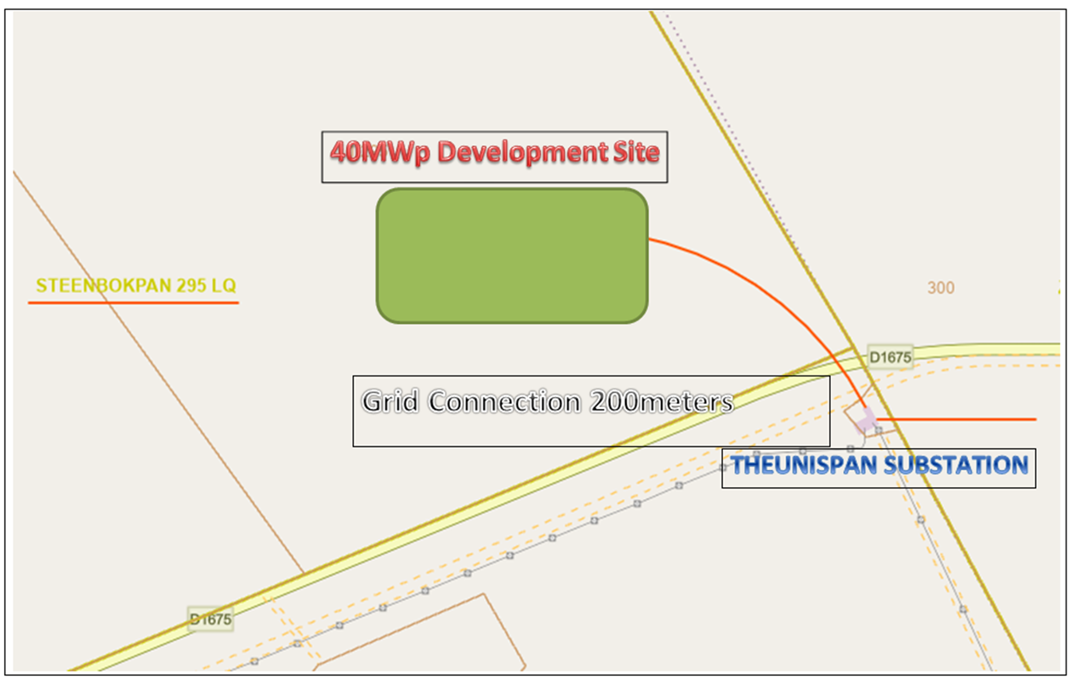
152MWp Development Site
Grid Connection 14km new 132kV line
Medupi MTS

